Google's V8 engine and Node.js

In 2009 Google created its Google Chrome browser that freed javascript from its web prison thanks to its V8 JavaScript engine.

The engine is the software that interprets the JavaScript code and run a script according to the instructions given. All web browsers have a JavaScript engine, Safari uses JavaScriptCore, FireFox uses SpiderMonkey, Microsoft Edge uses Chakra and in this case Google Chrome with V8, which tIt is also partly the Nodejs engine.

In these engines, the interpreter and compiler run simultaneously. The interpreter executes the source code almost immediately. The compiler translates the source code into machine code that the user's system executes directly.

The engine is independent of the browser, and can be used outside of it to execute javascript. This is what node.js took advantage of to convert javascript into machine code that the computer can understand WITHOUT using any browser.

V8 can be embedded (encapsulated) in applications written in C ++. Node is written in this language. We could summarize the operation of javascript and node in a scheme like this:

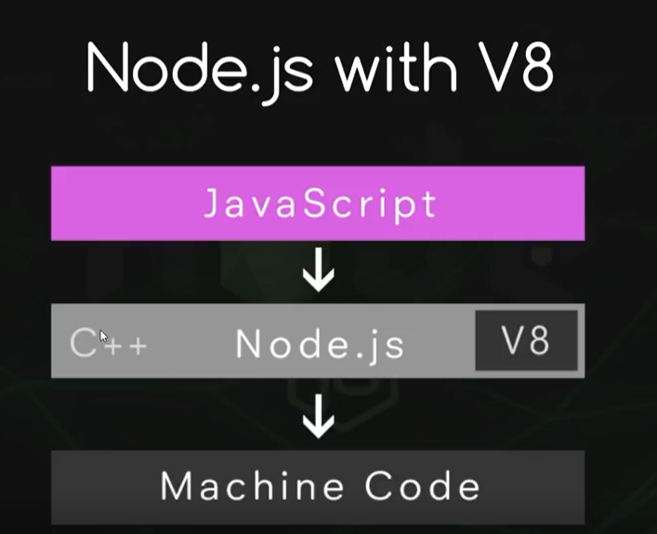
To expand on the subject I leave you this link and the original presentation from node creator Ryan Dahl.

The global object

The initial object of the hierarchy in Javascript within a browser would be the window, window. However, in node we are not inside the browser, and the global object is just that, the global object, and it is called global, although it is not necessary to write it. Through it, we can access a series of methods and properties as we can see in the node page

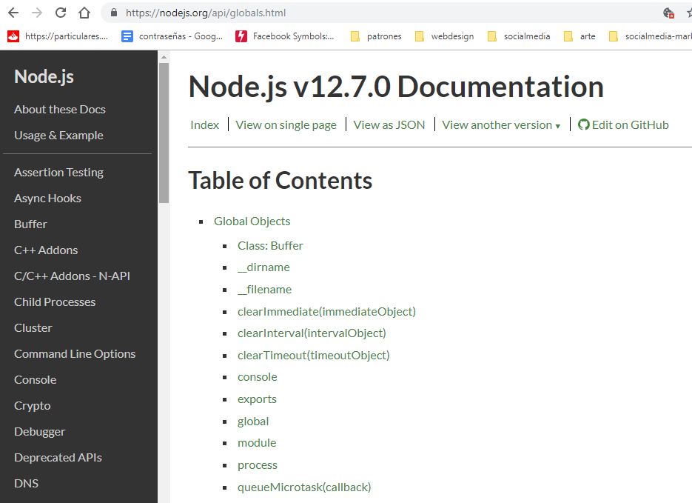
We have already used the console method, we are going to use other things.

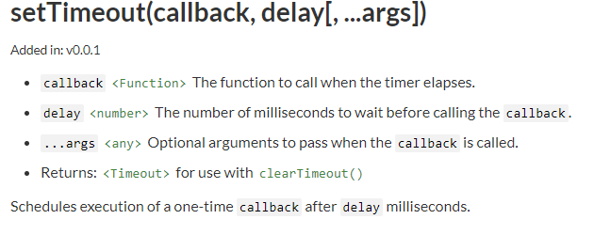
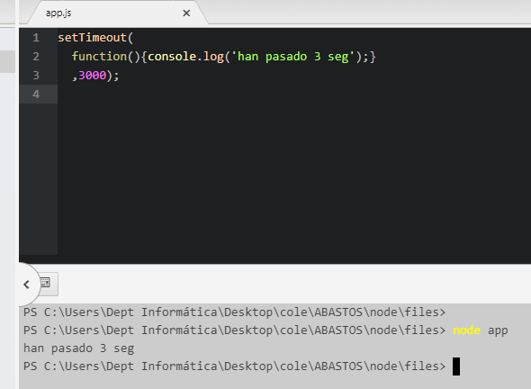

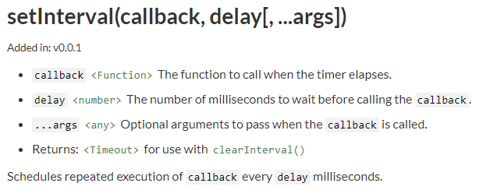

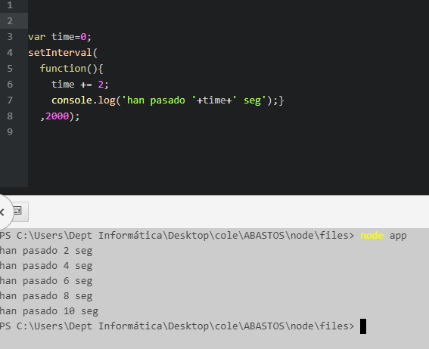
We stop this process with Ctrl + C in the terminal.

To make it stop according to a condition we use clearInterval

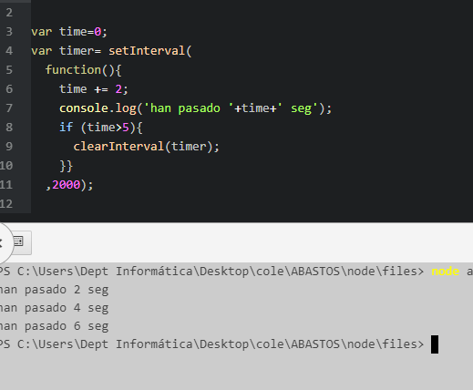
The __filename and __dirname properties give us the working directory and the file of our app.

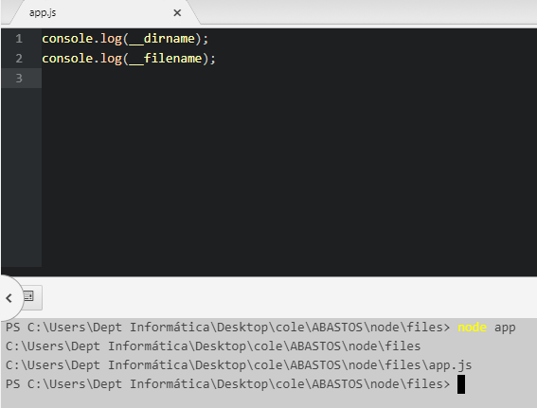

Blog entrance about global objects

https://www.hektorprofe.net/curso/nodejs-para-principiantes/objeto-global

